Print Statements

1. What Are Print Statements?

* Print Statements are how Java outputs to the console.
* These include
  + System.out.println(“”);
  + System.out.print(“”);
  + We will only use “System.out.println(“”);” really at all.
* While these may seem useless, they are very useful for debugging.

1. When to Use Print Statements

* Print Statements can print out text typed inside to the quotation marks and can also print out variables and Strings, even at the same time (Figure 1).
* The ability to print out values make debugging so much easier.

Figure 1, A Program that prints a directly typed in input, a string, and both at the same time.

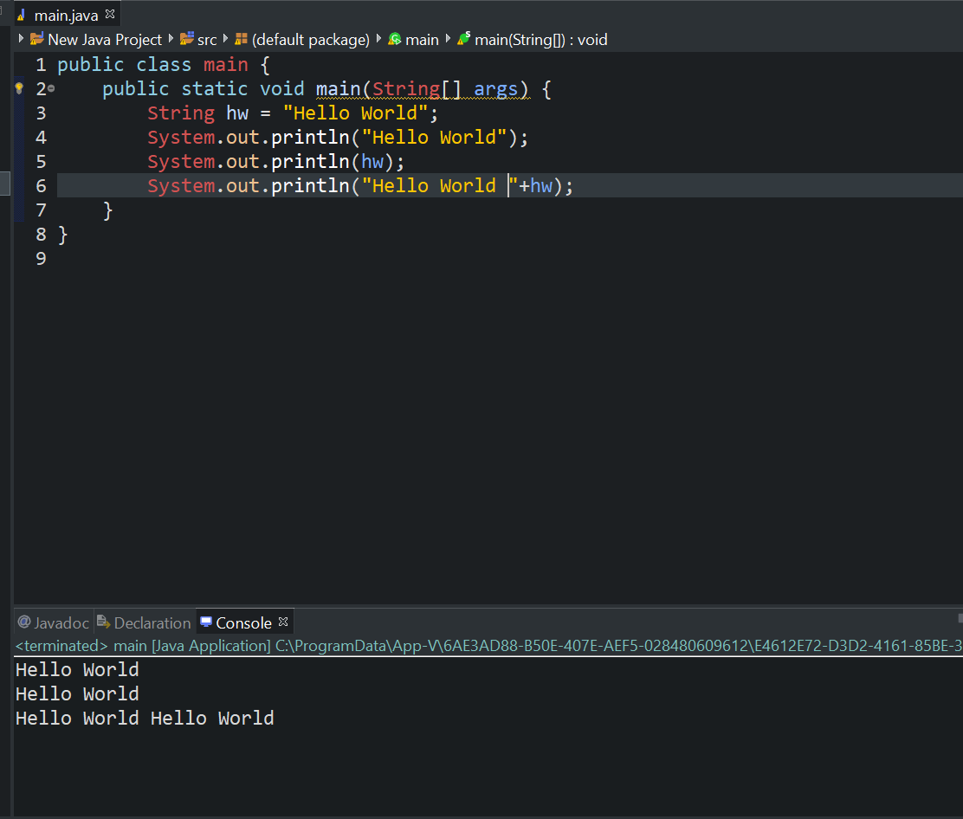

1. Recap

* Print statements print inputted text and values to the console.
* These are not used much in robotics but are very useful for debugging.